N-gonal Prismoid

Definition
# Source: AI Source: Provided by: [Data Path: Persons Table -> ID Column: 1, Name_En Column: Motasem Essam] -> From: [ChatGPT] on [7/25/2026]
An N-gonal Prismoid is a polyhedron formed by two parallel polygonal bases, each having $n$ sides and $n$ vertices, connected by $n$ quadrilateral lateral faces.
The two bases may differ in size, shape, or orientation, provided that the corresponding vertices and edges are arranged so that every lateral quadrilateral is planar.
The term N-gonal indicates that the bases can have any number $n$ of sides, where $n$ is an integer greater than or equal to 3.
Examples include:
- Triangular Prismoid ($n=3$)
- Quadrilateral Prismoid ($n=4$)
- Pentagonal Prismoid ($n=5$)
- Hexagonal Prismoid ($n=6$)
- Heptagonal Prismoid ($n=7$)
- Octagonal Prismoid ($n=8$)
- Nonagonal Prismoid ($n=9$)
- Decagonal Prismoid ($n=10$)

Geometric Structure
# Source: AI Source: Provided by: [Data Path: Persons Table -> ID Column: 1, Name_En Column: Motasem Essam] -> From: [ChatGPT] on [7/25/2026]
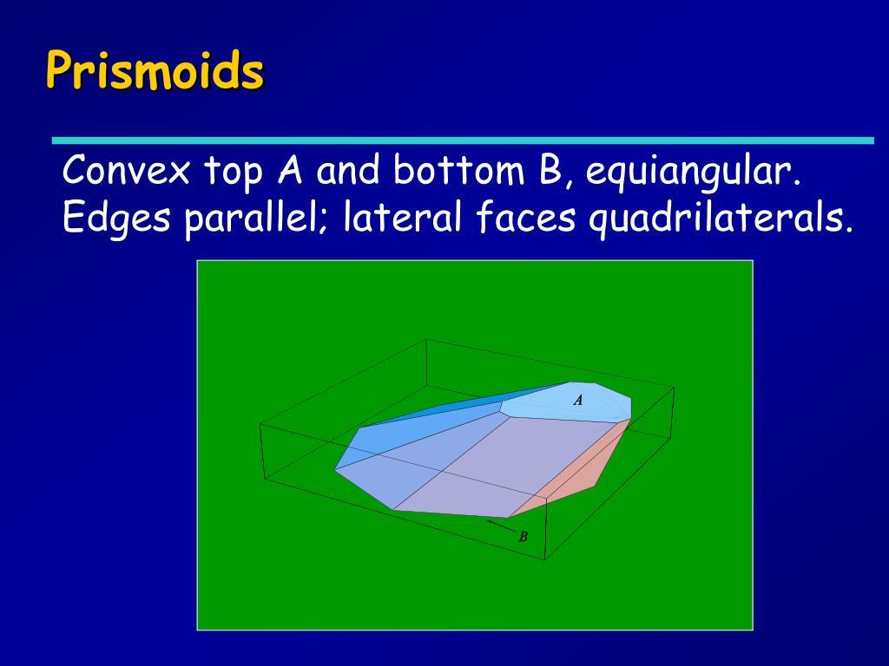
Its main elements are:
- Lower N-gonal Base: The bottom polygon with $n$ sides.
- Upper N-gonal Base: The top polygon with $n$ sides, parallel to the lower base.
- Lateral Faces: $n$ quadrilateral faces connecting corresponding sides of the two bases.
- Lateral Edges: $n$ edges connecting corresponding vertices of the bases.
- Vertices: $2n$ vertices in total.
- Altitude: The perpendicular distance between the two base planes.
- Midsection: A cross-section parallel to the bases, halfway between them.

Face Composition
# Source: AI Source: Provided by: [Data Path: Persons Table -> ID Column: 1, Name_En Column: Motasem Essam] -> From: [ChatGPT] on [7/25/2026]
An N-gonal prismoid has the following face arrangement:
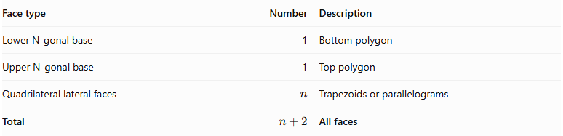
Face type | Number | Description
Lower N-gonal base | 1 | Bottom polygon
Upper N-gonal base | 1 | Top polygon
Quadrilateral lateral faces | $$n$$ | Trapezoids or parallelograms
Total | $$n+2$$ | All faces

Mathematical Properties
# Source: AI Source: Provided by: [Data Path: Persons Table -> ID Column: 1, Name_En Column: Motasem Essam] -> From: [ChatGPT] on [7/25/2026]
For an N-gonal prismoid, where $n$ is the number of sides of each base:
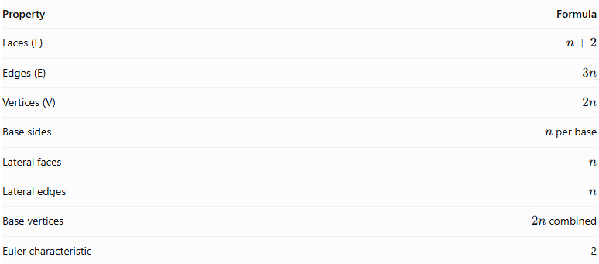
Property | Formula
Faces (F) | $$n+2$$
Edges (E) | $$3n$$
Vertices (V) | $$2n$$
Base sides | $n$ per base
Lateral faces | $$n$$
Lateral edges | $$n$$
Base vertices | $2n$ combined
Euler characteristic | 2
Euler's Formula:
$$V-E+F=2$$
Substituting the general formulas:
$$2n-3n+(n+2)=2$$
Volume — Prismoidal Formula:
$$V=\frac{h}{6}(A_{1}+4A_{m}+A_{2})$$
Where:
- $A_{1}$ = Area of the lower base.
- $A_{2}$ = Area of the upper base.
- $A_{m}$ = Area of the midsection parallel to the bases.
- $h$ = Perpendicular distance between the base planes.

Area of a Regular N-gon:
$$A=\frac{{ns}^{2}}{4tan(\frac{{180}^{∘}}{n})}$$
Where:
- $n$ = Number of sides.
- $s$ = Side length of the regular polygon.

Geometric Characteristics
# Source: AI Source: Provided by: [Data Path: Persons Table -> ID Column: 1, Name_En Column: Motasem Essam] -> From: [ChatGPT] on [7/25/2026]
- It has two parallel polygonal bases.
- Both bases have the same number of sides and vertices.
- It has $n$ quadrilateral lateral faces.
- Its lateral faces are trapezoids or parallelograms.
- The bases may differ in size and shape.
- Its altitude is measured perpendicular to the base planes.
- Its midsection is parallel to both bases.
- Its number of faces, edges, and vertices depends on $n$.
- It satisfies Euler's polyhedron formula when it forms a closed, non-degenerate polyhedron.

Types of N-gonal Prismoids
# Source: AI Source: Provided by: [Data Path: Persons Table -> ID Column: 1, Name_En Column: Motasem Essam] -> From: [ChatGPT] on [7/25/2026]
N-gonal prismoids can be subdivided according to the geometry of their bases:
- Regular N-gonal Prismoid: Both bases are regular N-gons.
- Irregular N-gonal Prismoid: At least one base is an irregular N-gon.
- Similar-Bases N-gonal Prismoid: The two bases are similar polygons.
- Non-Similar-Bases N-gonal Prismoid: The two bases are not similar polygons.
These are descriptive classification categories rather than universally standardized solid names.

Constructing a N-gonal Prismoid

Geometric Instruments
# Source: AI Source: Provided by: [Data Path: Persons Table -> ID Column: 1, Name_En Column: Motasem Essam] -> From: [ChatGPT] on [7/25/2026]
The following instruments can be used to construct an N-gonal prismoid using traditional geometric drawing methods:
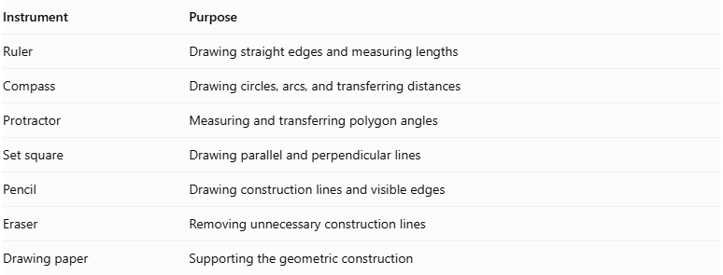
Instrument | Purpose
Ruler | Drawing straight edges and measuring lengths
Compass | Drawing circles, arcs, and transferring distances
Protractor | Measuring and transferring polygon angles
Set square | Drawing parallel and perpendicular lines
Pencil | Drawing construction lines and visible edges
Eraser | Removing unnecessary construction lines
Drawing paper | Supporting the geometric construction
Important note about regular N-gons: The exact construction method depends on the value of $N$. Some regular polygons can be constructed using only an unmarked straightedge and compass, while others require additional instruments or approximate construction methods. A protractor can be used for practical angle-based construction.

Instrument-Based Construction Procedures

Method 1: Constructing from Two Parallel N-gonal Bases
# Source: AI Source: Provided by: [Data Path: Persons Table -> ID Column: 1, Name_En Column: Motasem Essam] -> From: [ChatGPT] on [7/25/2026]
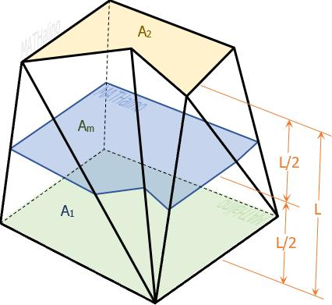
- Determine the number of sides $N$ for the required polygonal bases.
- Draw the lower N-gonal base $A_{1}A_{2}…A_{N}$ using a ruler, compass, and suitable angle-measuring instrument.
- Establish the required perpendicular height above the lower base.
- Draw the upper N-gonal base $A'_{1}A'_{2}…A'_{N}$ in a plane parallel to the lower base.
- Choose the dimensions and positions of the upper polygon so that the corresponding connecting edges produce planar lateral quadrilaterals.
- Connect each lower vertex to its corresponding upper vertex.
- Join the corresponding base edges to form the $N$ lateral quadrilaterals.
- Verify that all lateral faces are planar.
- Erase unnecessary construction lines and distinguish visible edges from hidden edges.

Method 2: Constructing from an N-gonal Base and Its Parallel Upper Section
# Source: AI Source: Provided by: [Data Path: Persons Table -> ID Column: 1, Name_En Column: Motasem Essam] -> From: [ChatGPT] on [7/25/2026]
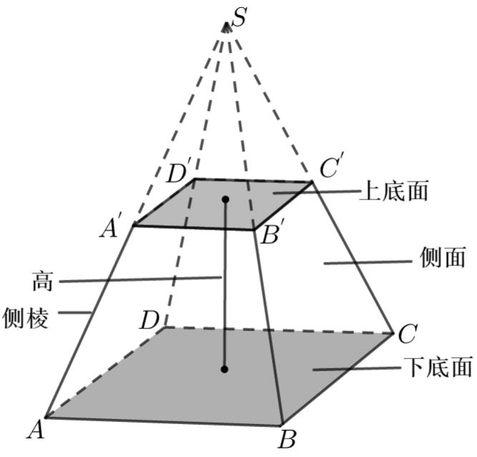
- Construct the lower N-gonal base.
- Draw a parallel upper construction plane at the required perpendicular height.
- Construct a second N-gon on the upper plane.
- Determine the corresponding positions of all $N$ upper vertices.
- Check that each pair of corresponding base edges and connecting lateral edges defines a planar quadrilateral.
- Connect the corresponding vertices.
- Complete all $N$ lateral faces.
- Verify that the two bases are parallel.
- Finalize the drawing by removing auxiliary lines and marking visible and hidden edges.

Method 3: Constructing Through Parallel Cross-Sections
# Source: AI Source: Provided by: [Data Path: Persons Table -> ID Column: 1, Name_En Column: Motasem Essam] -> From: [ChatGPT] on [7/25/2026]
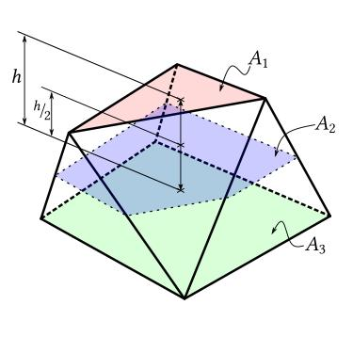
- Draw the lower N-gonal base.
- Establish the perpendicular height of the solid.
- Mark the halfway level between the two bases.
- Construct a middle N-gonal cross-section parallel to both bases.
- Construct the upper N-gonal base.
- Connect the corresponding vertices of the lower, middle, and upper polygons.
- Ensure that the resulting lateral faces are planar quadrilaterals.
- Complete the visible and hidden edges.
The middle cross-section is used when calculating the volume with the prismoidal formula.

Related Geometric Solids
# Source: AI Source: Provided by: [Data Path: Persons Table -> ID Column: 1, Name_En Column: Motasem Essam] -> From: [ChatGPT] on [7/25/2026]
- N-gonal Prism: A special case with congruent polygonal bases and parallelogram lateral faces.
- N-gonal Pyramidal Frustum: A prismoid whose bases are similar polygons and whose lateral faces are trapezoids.
- N-gonal Prismatoid: A broader related classification that includes polyhedra with vertices in two parallel planes.
- N-gonal Antiprism: A related solid with two parallel polygonal bases connected by triangular lateral faces.

Main Classification
# Source: AI Source: Provided by: [Data Path: Persons Table -> ID Column: 1, Name_En Column: Motasem Essam] -> From: [ChatGPT] on [7/25/2026]
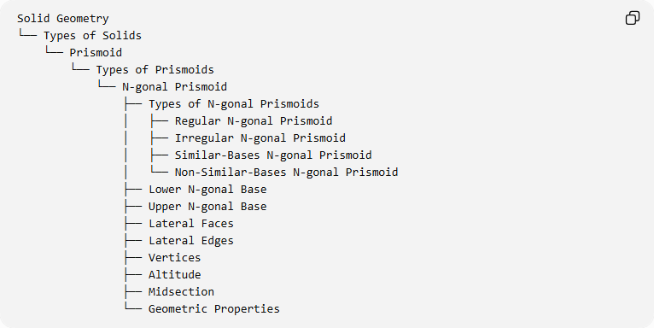
Solid Geometry
└── Types of Solids
└── Prismoid
└── Types of Prismoids
└── N-gonal Prismoid
├── Types of N-gonal Prismoids
│ ├── Regular N-gonal Prismoid
│ ├── Irregular N-gonal Prismoid
│ ├── Similar-Bases N-gonal Prismoid
│ └── Non-Similar-Bases N-gonal Prismoid
├── Lower N-gonal Base
├── Upper N-gonal Base
├── Lateral Faces
├── Lateral Edges
├── Vertices
├── Altitude
├── Midsection
└── Geometric Properties

Key Points
# Source: AI Source: Provided by: [Data Path: Persons Table -> ID Column: 1, Name_En Column: Motasem Essam] -> From: [ChatGPT] on [7/25/2026]
- An N-gonal prismoid has two parallel bases with the same number of sides.
- Each base contains $n$ sides and $n$ vertices.
- It has $n$ quadrilateral lateral faces.
- Its total number of faces is $n+2$.
- Its total number of edges is $3n$.
- Its total number of vertices is $2n$.
- Its volume is calculated using the prismoidal formula.

Conclusion
# Source: AI Source: Provided by: [Data Path: Persons Table -> ID Column: 1, Name_En Column: Motasem Essam] -> From: [ChatGPT] on [7/25/2026]
The N-gonal Prismoid represents the general form of prismoids with polygonal bases. Its geometric structure is determined by the number of sides $n$, allowing it to represent triangular, quadrilateral, pentagonal, hexagonal, and higher-sided prismoids within one general classification.

